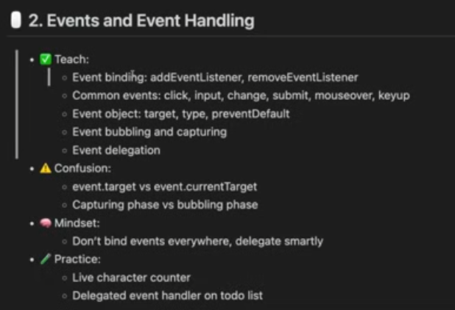
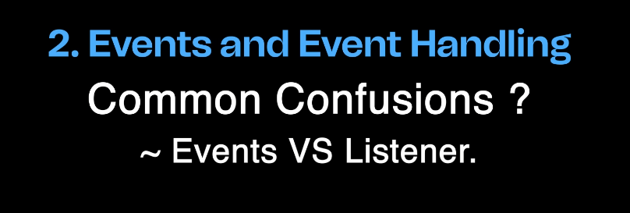
Event -> click
Event Listener -> function jo likh rakha hai.
p.addEventListener(“click”, ()=>{
});
Click event ko listen karke uspar event listener jo function hai wo kaam Karega.

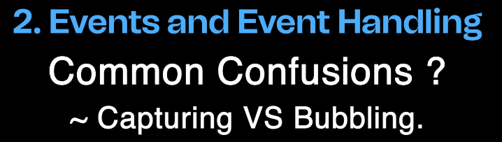
Capturing -> phase 1 top to bottom
Bubbling -> phase 2 bottom to top
Hamesha agar child pe bhi click kiya hai toh bhi pehle capturing hogi phase 1 then bubbling phase 2.

